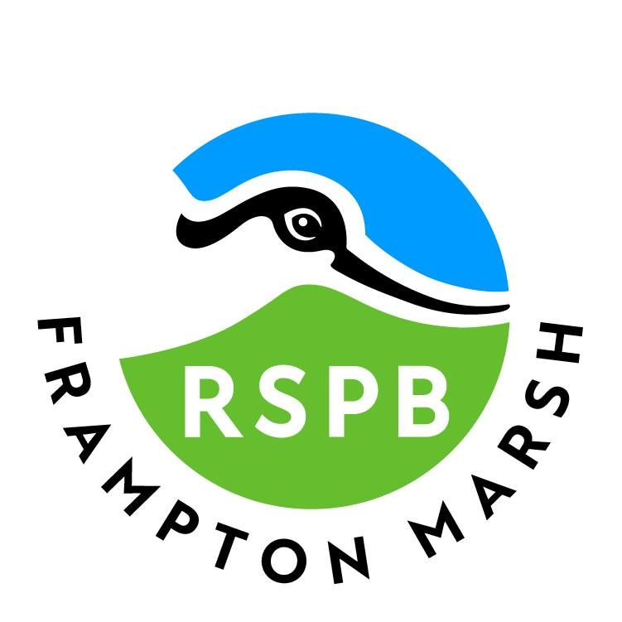

This access statement does not contain personal opinions as to our suitability for those with access needs but aims to accurately describe the facilities and services that we offer all our guests/visitors.

Accessibility Guide for RSPB Frampton Marsh
lincolnshirewashreserves@rspb.org.uk
01205 724678
www.rspb.org.uk/framptonmarsh

Introduction
RSPB Frampton Marsh is situated on ‘The Wash’, one of the best wetlands for wildlife in Europe with lots of different habitats to explore including reedbeds, wet grassland, freshwater scrapes and one of the largest saltmarshes in the world!
It plays host to a variety of species of birds, invertebrates, and mammals. Families are always made welcome to the reserve by our friendly team and always head home knowing they have had a connection with nature. Our new café facility also allows our visitors to take in spectacular views of the reedbed, while enjoying a meal.
The reserve is situated within the agricultural Lincolnshire landscape and is reached along quiet, generally single lane, rural roads with a slight incline leading up to the car park.
There is a choice of routes around the reserve. Major paths are made of compacted unbonded aggregate leading to three viewing hides. Other routes include slopes, grass paths with slight undulations. Further details about the reserve and what you can see and do can be found on our website at: https://www.rspb.org.uk/days-out/reserves/frampton-marsh
We look forward to welcoming you to the reserve. If you have any queries or require any assistance, please phone 01205 724678 or email lincolnshirewashreserves@rspb.org.uk.
The visitor centre
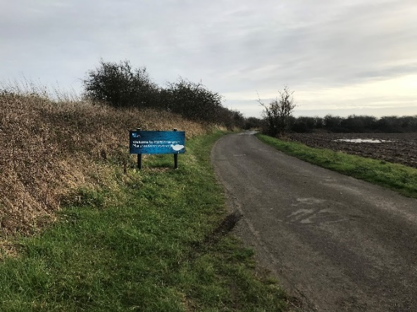
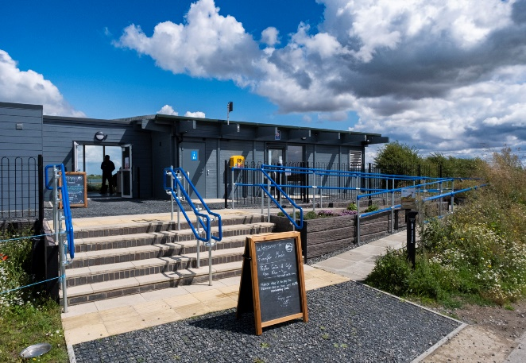

Pre-Arrival
- For a map and directions of how to reach us please see the ‘How to get here’ section of our website, which has a link for sat navs. Alternatively, you can plan your journey by car using https://www.theaa.com/route-planner/route; simply enter your postcode and ours, to get directions. The approach road to Frampton Marsh is level and in good condition but does not have a pavement. There is a slight incline leading up to the reserve, but the majority of the approach is flat.

- The nearest railway station is Boston, which is about four miles (6.4 km) away. Taxis are available from the station and will cost approximately £15-19 (each way). Head along the A16 towards Kirton, follow the brown signs to RSPB Frampton Marsh.

- The nearest bus stop is in Kirton village, approximately three miles (5 km) from the reserve entrance. Bus route B3X/B3 and B8 goes through Kirton from Boston bus station (which is four miles away) Monday to Friday. Bus route B13 does this on a Saturday. These services run Monday to Friday. For bus times check https://lincsbus.info
- The reserve is also served by the ‘Call Connect’ on demand bus service from Boston. This operates 7am – 7pm weekdays, 8am – 6pm Saturday. For more details call 0845 2343344 or visit https://lincsbus.info/callconnect

- The reserve is open at all times and entrance is free for everyone.

- The Visitor Centre and Cafe is open from 10am to 4pm daily (Last hot food orders in the Café at 3:00pm).

The facilities are closed on Christmas Eve, Christmas Day and Boxing Day.

- Registered assistance dogs are welcome on the reserve.

Car Parking Facilities and Arrival
- Parking is free for RSPB members, and £6 for non-members.
- 60 parking spaces are provided within 40 meters from the main entrance/visitor centre on the opposite side of the entrance road. The car park surface is loose aggregate.
- Five ‘Blue Badge’ spaces are provided within 24 meters of the visitor centre entrance. A level cement path leads to a single lane road and to the visitor centre access.

- There is no lighting in the car park area or around the reserve.

- Visitors can be dropped off outside the visitor centre.

- Entrance to the visitor centre is either via five steps or a ramp, both with handrails on either side. The main entrance has double, outward opening, automatic doors, which are often secured open during summer. During opening times, a member of the team is available to provide assistance if required. The door opening is 1500 mm (59 inches). There is a second automatic outward opening door at the other side of the foyer which leads to the reserve and is 800 mm (31.5 inches) wide.

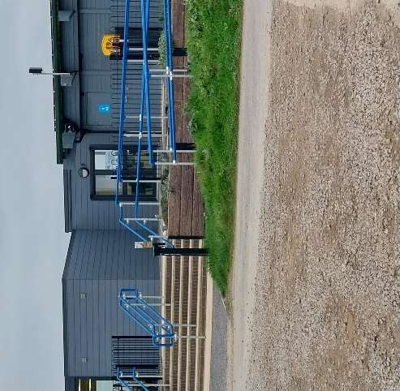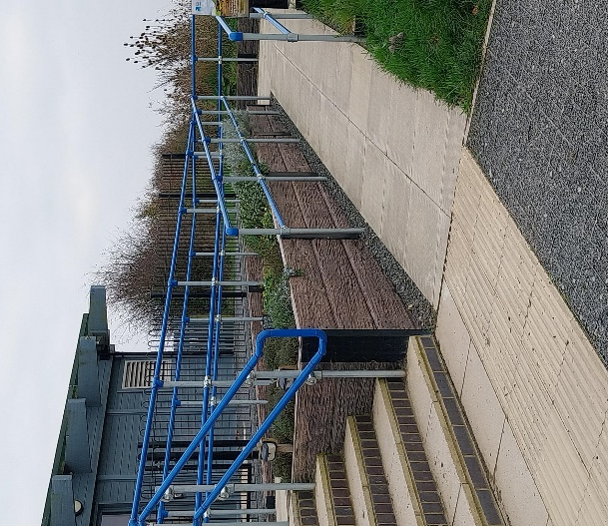
Approach to the visitor centre from the car park and access via the ramp

Visitor Centre
- Entry is by five steps or a ramp, both with handrails on either side. Once inside the flooring is level, step free throughout, the foyer and toilets have anti-slip flooring.

- The information desk is located about three meters from the main entrance.

- Seating is available inside, with low chairs with backs and arms. There are two higher chairs with backs and arms.

- The area is evenly and well-lit with overhead spotlights and general lighting operating when required.

- You can get close views of wildlife from the visitor centre, where telescopes are provided; these are fully adjustable. During visitor centre opening times an RSPB guide will be on hand and happy to answer any questions. Binoculars can be hired from the visitor centre and taken out around the reserve. These are available at £7 a pair.

- There are also nature quest backpacks available which are perfect for younger visitors with small binoculars, bug pots and activities to take around the reserve for a fee of £6 per person.

- Pond dipping equipment is also available to hire, for £3 per person.

- All information displayed throughout the visitor centre is in a clear print format.

- Event information is also available in the visitor centre.

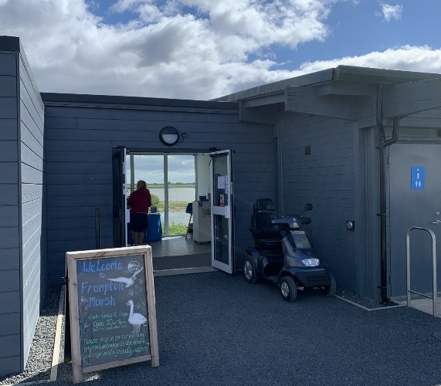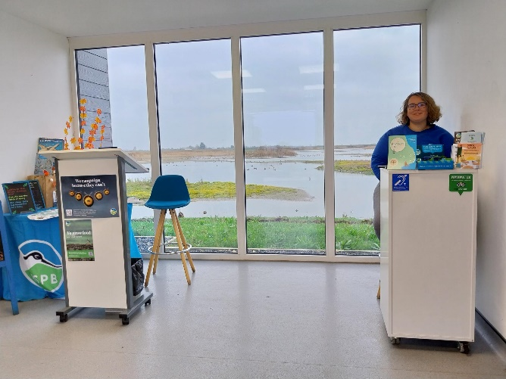
Reception desk
Main entrance to the visitor centre

Catering
- The café serves a range of hot and cold meals and snacks (including gluten-free and plant-based) and hot and cold drinks. Assistance in the café is available upon request.
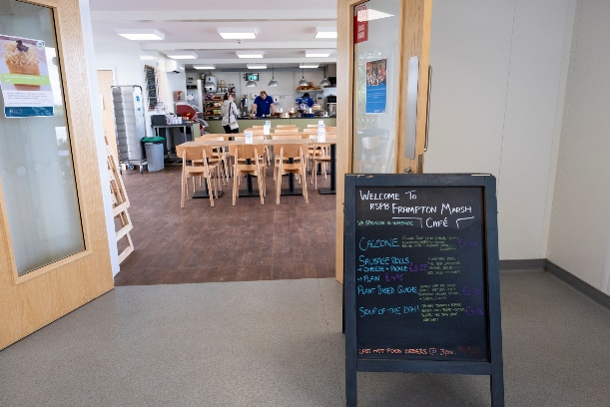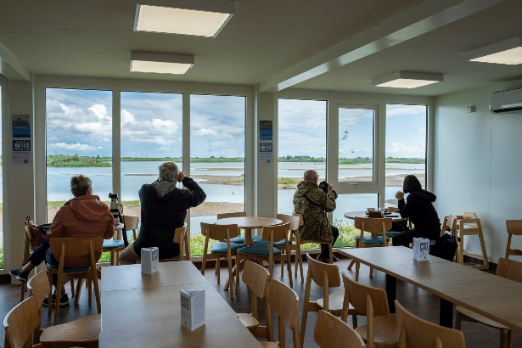

Public Toilets
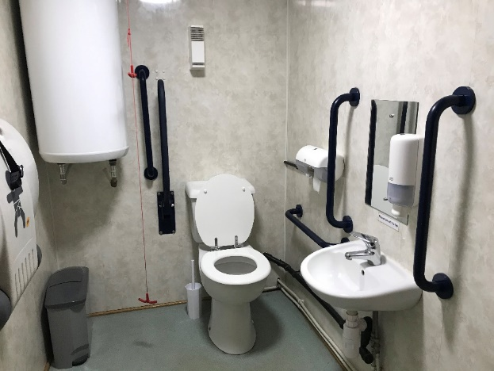
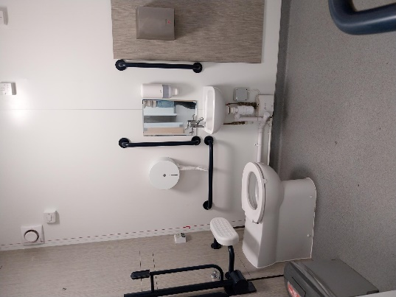
The accessible toilets
- There are five unisex toilets situated in the visitor centre and an outside 24-hour toilet. Two are unisex accessible toilets. One is about 3 metres from the main entrance and has level access from the door. The toilet door opens outwards, is 930 mm (37.6 inches) wide and can be locked with a lever handle.

- The toilet has non-slip flooring. The toilet dimensions are 1730 mm x 2200 mm (68.1 inches by 86.6 inches). The transfer space is on the left as you face the WC and is 1070 mm (42.1 inches) wide. There is a toilet roll holder 960 mm (37.8 inches) from the floor. The height of the toilet seat above the floor is 485 mm (19.1 inches). As you face the WC there are wall mounted horizontal and vertical grab rails on the right and a drop-down rail on the left.

- The sink is 730 mm (28.7 inches) high and has lever type taps.

- Guests can alert the member of staff if assistance is needed using the red alarm cord to the right of the WC (as you face it). The light switch is on the left as you enter the toilet.

- The other is about 5 metres from the main entrance, near the exit door to the reserve and has level access from the door. The toilet door opens outwards, is 960 mm (37.8 inches) wide and can be locked with a lever handle.

- The toilet has non-slip flooring. The toilet dimensions are 1460 mm x 2180 mm (57.5 inches by 85.8 inches). The transfer space is on the left as you face the WC and is 840 mm (33.1 inches) wide. There is a toilet roll holder 890 mm (35 inches) from the floor. The height of the toilet seat above the floor is 485 mm (19.1 inches). As you face the WC there are wall mounted horizontal and vertical grab rails on the right and a drop-down rail on the left.

- The sink is 680 mm (27.8 inches) high and has lever type taps.

- Guests can alert the member of staff if assistance is needed using the red alarm cord to the left of the WC (as you face it). The toilet is lit by movement sensitive lighting.

- Baby changing facilities are available in both accessible toilets. The baby changing table pulls down and is accessible from a seated position.

- Also within both toilet cubicles are a hand dryer and sanitary disposal facilities.

Picnic Area
- There is a picnic area in front of the visitor centre. There are four picnic benches at varying distances from the main entrance; one of the picnic tables has a space for a wheelchair user. Each picnic table has a dog hitching post. There are 2 further picnic tables to the left of the visitor centre. Visitors can bring their own food and drink to use in the picnic areas.

Additional Information
- There is a water bowl available for dogs outside the visitor centre.
- There is a bike rack to the left of the steps up to the visitor centre with space for 10 bikes.

Nature Trails

The main trails explore the reserve;
- The Reedbed Trail is a 1.2 miles (2km) circular walk starting at the visitor centre and takes about 45 minutes to complete. The path is flat and made of compacted, but unbonded aggregate. There are three gates to open, with a passing width of 114-127cm (45-50 inches to open).

- The Wash Trail is about a 2.2 mile (3.5km) circular walk which takes about 1 ½ hours to complete. The walk includes compacted unbonded aggregate paths, steps, slopes, grass paths and uneven ground. There are three gates to open.

- The wet grassland trail is about 2.8 miles (4.5 km). This trail takes around two hours to complete. The walk includes compacted unbonded aggregate paths, slopes, grass paths and uneven ground. There are three gates to open.

- Further information about trails can be obtained from the RSPB guide in the visitor centre. The gates along the paths are 1145 mm (45 inches) wide.

- Simple (i.e. backless) benches are situated at viewpoints at varying distances. There are a further five benches with back and arm rests, including one on the pond dipping platform and two on raised, gravel mounds.

- There are information boards around the reserve which are printed in a clear format and can be read from a seated position.

Viewing Facilities
- Three viewing hides are available. Two are on the reedbed trail and the third is a short distance off this route. There is level access to the 360 hide and the East hide. The reedbed hide has ramp access.

- There is a predator gate on the path leading to the 360 hide. All hides have clear door widths of 925 mm (36.4 inches) with a lever style handle 1230 mm (48.4 inches) from the floor. Once inside the hides are level throughout with simple, moveable benches 530 mm high and space for wheelchairs.

- Each hide has low windows at a height of 975 mm – 1290 mm (38.4 – 50.8 inches) from the floor – reed bed hide – wheelchair level window. The windows open upwards and are secured with a latch. All information displayed is in a clear print format with a matt finish.

Pond Dipping

- Pond dipping may be carried out from a platform accessed from the reedbed trail. The platform is made from non-slip recycled plastic.
- The dimensions of the platform are 3860 mm by 207 mm. Access to the platform is via a walkway 1470 mm wide and 4550mm long.
- Access onto the walkway is uneven, with a 20 mm step up
- One edge of the platform and walkway is bounded by a safety rail, 980 mm in height.
- A bench, with arms and back, is provided on the platform

Contact Information
Address (Inc postcode): | RSPB Frampton Marsh Roads Farmhouse Frampton Boston PE20 1AY
Telephone: | 01205 724678
Email: | lincolnshirewashreserves@rspb.org.uk
Website: | https://www.rspb.org.uk/days-out/reserves/frampton-marsh
Grid Reference:  What3words: | TF356392  ///surround.humans.nylon
Hours Of Operation: | The reserve is open 24 hours. However, the visitor facilities are open 10am to 4pm (Café last orders at 3.30pm).  The Visitor Centre and Café is closed on Christmas Day.
Local Equipment Hire: | Town & Country Mobility hire mobility equipment and can deliver if needed. Tel: 01205 838105 www.townandcountrymobility.com
Local Accessible Taxi: | There are several local taxi firms including Acorn Taxis which have vehicles suitable for both electric and manual wheelchairs. On request they also have vehicles which can take up to four wheelchairs. Their phone number is 01205 358358.

