Blue Badge Parking 1
Pick up / Drop Point 2
Access Scheme 3
Venue Accessibility 4
Early entry to the venue 5
Accessible toilets 5
Changing Places 6
Quiet Spaces 6
Registered Assistance Dogs 6
Large Print Menus 7
Hearing Assistance 7
Sensory Packs 7
Ear Plugs 8
Venue Accessibility Tours 8
Accessibility of each level 8
Stalls 9
Basement 11
Boiler Room Bar 12
Ballroom 16
Upper Circle 18
Steps Information 20

Blue Badge Parking

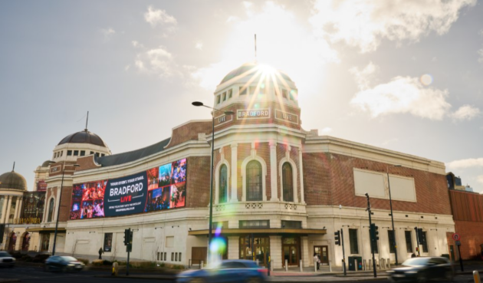

Bradford Live is located in the city of Bradford, West Yorkshire and is accessible by train, bus, coach and car. The venue is situated on Godwin Street next door to the Alhambra Theatre and opposite the Mirror Pool in City Park.

There are blue badge spaces located at the front of the Alhambra Theatre on Morley Street. You can access the Morley Street spaces using Great Horton Road at the side of the theatre. There is a bollard system which will check your Blue Badge and allow access round the front of the theatre to the parking bays on Morley Street (BD7 1AJ). Spaces are on a first come, first serve basis - parking can be for 5hrs (no return within 1hr).

If Morley Street spaces have all been taken, the next closest are located behind the City Library on Aldermanbury (BD1 1SD). This is on street parking, first come first served. This is situated just across the road from us, a 3-4min walk.

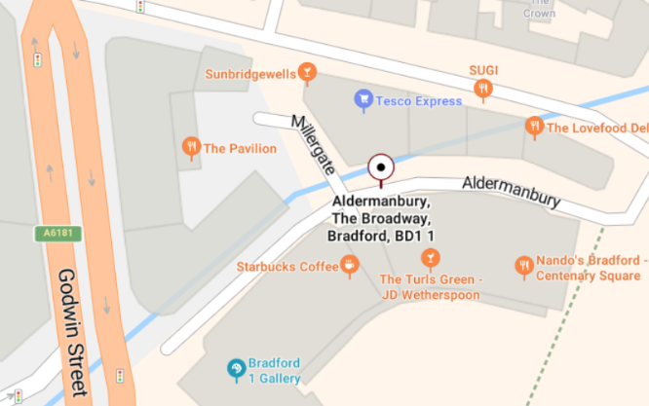

Pick up / Drop Point

The nearest drop-off / pick up point is located on Thornton Road, at the side of the venue close to our North entrance with step free access.

Access Scheme
We operate an Access Scheme that provides a free Essential Companion ticket. To register, please complete the registration form which will be sent to our box office team when submitted. Please then email BoxOffice.Bradford@trafalgar.global the required proof (details are outlined on the form).
Individual: Bradford Live Access Registration Form – Fill in form
Organisation: Organisation Access Registration Form – Fill in form
Any proof you provide that contains sensitive or personal information will be securely deleted once it has been verified.
Please allow up to five working days for your registration to be processed.
For all future bookings, Access/Essential Companion tickets can be reserved by telephone (0343 310 0026) or by email BoxOffice.Bradford@trafalgar.global. Online booking for Access tickets is currently in development and undergoing testing.

Venue Accessibility

Access to the venue is step-free, both via the South Entrance where the Box Office is located (next to Alhambra Theatre), which leads directly into the Stalls/Foyer Bar area and also from the North entrance on Thornton Road.

Assistance is available immediately on entrance into the venue. The box office counter, as with all our service points, has a wheelchair-accessible section. All six bars have accessible counters.

Early entry to the venue
If you require early entry to avoid queues, you can access the Box Office Foyer via the South Entrance (next to the Alhambra Theatre) 10 minutes before the general venue opening time. Once the venue is fully open, you will be allowed entry ahead of the main doors opening. Please contact box office at BoxOffice.Bradford@trafalgar.global ahead of time so we know when to expect you.

Lifts
There are two lifts that will take to each floor of the venue.

Accessible toilets are available on each level and can be opened using a radar key.

On the ground floor (Stalls level) there are three accessible toilets located by doors B,C and D into the stalls.

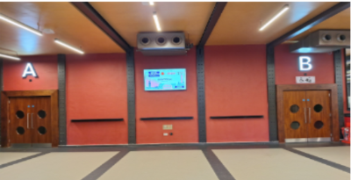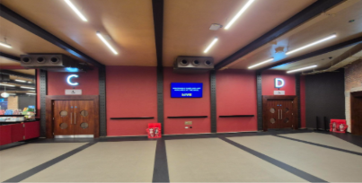

The Circle level has one accessible toilet, located just off from the Circle bar/foyer area.

The Upper Circle level has two accessible toilets situated at the rear of the level, one located by Door H and the other by Door J. Both doors also have access to the lifts.

Changing Places

We also have a changing facility on this level which includes:
- A height-adjustable, adult-sized changing bench
- A tracking hoist system
- Adequate space for the disabled person and up to two carers
- A centrally placed toilet with space on either side for carers
- A large waste bin for disposable pads
- A non-slip floor
This is situated on the Stalls level by Door B, just off from the main Stalls Foyer.

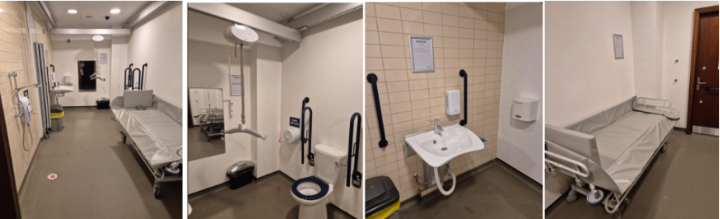

Quiet Spaces
We have a dedicated quiet space located in our Treatment room, which is on the basement level. This can be reached via steps or lift. Please speak with a member of staff should you have need of this space on your visit.

Registered Assistance Dogs
Registered Assistance Dogs are welcome throughout the venue. If you would like to attend with an assistance dog, please contact the box office: BoxOffice.Bradford@trafalgar.global

Large Print Menus
Large print menus are available at all bars

Hearing Assistance

The Loop System is available through the Sennheiser MobileConnect App. This is a ‘Bring your own device’ system to use with a smart phone & headphones or hearing aids.

Connect to the Wi-Fi: RE_Bradford_Mobile_Connect
Password: Mobile Connect
Once the app is downloaded, the choice to select audio feed is either:
- Show relay (Main Auditorium)
- Cabaret (Gaumont Bar)
- Ballroom

Sensory Packs
We recognise that busy event environments can sometimes be overwhelming for guests with sensory sensitivities. To help make your visit as comfortable and enjoyable as possible, we offer a limited number of Sensory Bags containing a range of supportive tools designed to help you feel relaxed, engaged, and able to make the most of your experience at Bradford Live.

Each Sensory Bag contains a selection of thoughtfully chosen sensory items that can provide comfort, stimulation, and support. Contents may vary, but can include items such as fidget spinners, Silishapes, sensory bars, and a variety of textured objects and tactile resources. These tools are designed to help users self-regulate, reduce stress, and enhance their overall experience. To reserve a pack, please contact the Box Office team directly: BoxOffice.Bradford@trafalgar.global

Ear Plugs
Disposable foam in-ear plugs are available at all bars. Please speak with our front of house team should you require them.

We have a limited number of Child ear defenders available from the box office. Please speak with a member of our front of house team should you require a pair for your child.

Venue Accessibility Tours
Venue accessibility tours can be booked directly through the Box Office team. Tours take place quarterly and are available in either the morning or afternoon. To find out the next available date, please contact the Box Office team directly: BoxOffice.Bradford@trafalgar.global

Accessibility of each level

Stalls (Wheelchair positions)
The Stalls level is our most accessible level for all requirements.
There is an accessible platform (Row ZO) located at the rear of the stalls level which is step free, near the exit/accessible toilets and offers a great view of the stage. It can accommodate twelve wheelchairs and 12 essential companions.
The seating in this area is free standing, ideal for patrons who need extra space, to be close to an exit/toilet or who need to remain in a wheelchair/scooter. This area is held off from general sale and can only be booked via telephone 0343 310 0026 or email BoxOffice.Bradford@trafalgar.global :

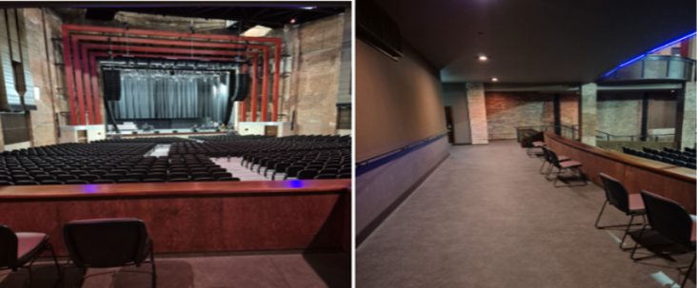
View From Accessible Platform Accessible Platform offers lot of additional space

From the platform area, there are five steps leading down to the main Stalls area with a handrail to assist, which has a sloped floor:

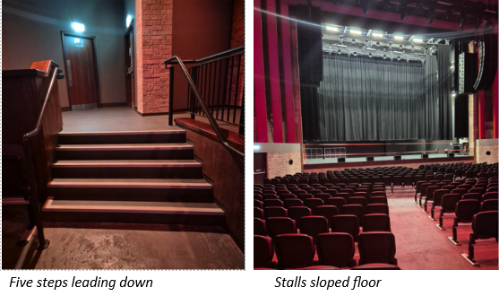
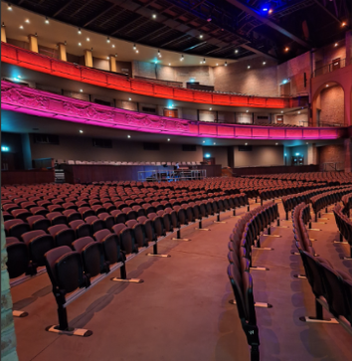
Rows J and ZA offer additional leg room

Rows J and ZA offer additional leg room as there is not a row directly in front. Row ZA 1-21 offers the best seating for those who would prefer to transfer from a wheelchair and is held off from general sale. These seats are closest to the step free access into the Stalls and to the area used to store the wheelchair during the performance.

Step-free access Stalls entrance to basement toilets (Accessible, Ladies and Gents) via ramp from stalls: 37 metres

Step free access into the Stalls can be accessed via the Gaumont Bar. The closest entrance is situated on Thornton Road, however if you enter the venue via the entrance

next to the Alhambra Theatre you can get to the lift, situated in corridor K, down to the Gaumont bar level.

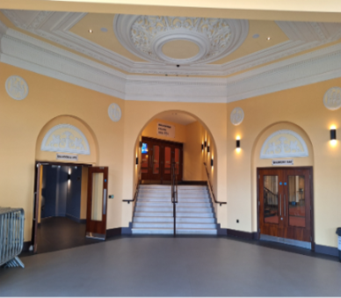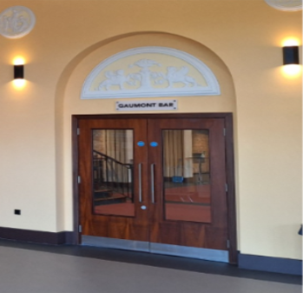
North Entrance

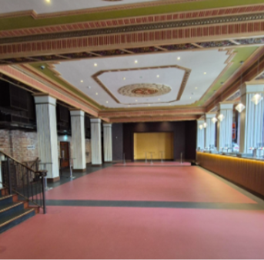
Gaumont Bar

North Entrance steps to Basement – 9 Steps
North Entrance steps to Stalls Foyer (both Corridor K and main entry stairway) - 10 Steps
Stalls Foyer to Gaumont Bar - 9 Steps

Basement (Boiler Room Bar, Ladies, Gents, Accessible toilet and Treatment Room)

This level can be accessed via the stairway just off from the Stalls Bar / Foyer, both lifts and via the step-free ramp from the Stalls level.

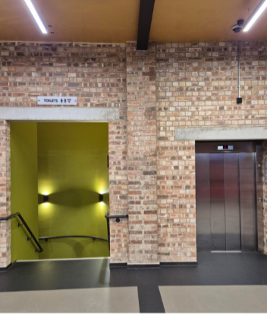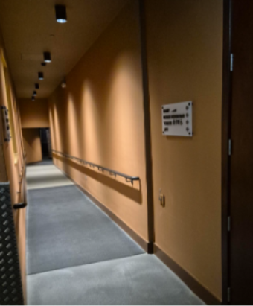
Stairway and lift via Stalls Bar/Foyer Step-free ramp via Stalls

For patrons who use a wheelchair, it is highly recommended to use either lift to access this level.

Steps from Stalls Foyer (next to Box Office) to Basement level – 18 steps
Steps from Stalls Foyer via Corridor K (Blue) to Basement level – 19 Steps

Boiler Room Bar
The Boiler Room Bar is located on the Basement Level, and can be accessed via two staircases from the Stalls Foyer and via the lift

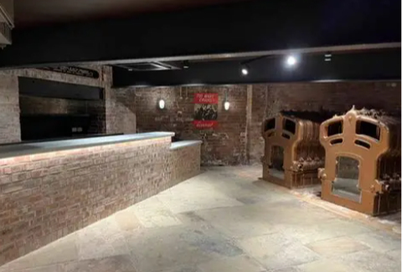

Steps from Stall Foyer (Green Staircase) to Basement level: 18 steps
Steps from Stalls Foyer via Corridor G (Yellow) to Basement level: 24 steps

Circle

The Circle Foyer and Bar can be reached via each stairway (G/Yellow and K/Blue) aswell as both lifts.

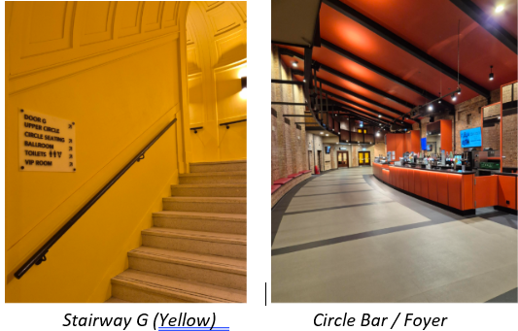

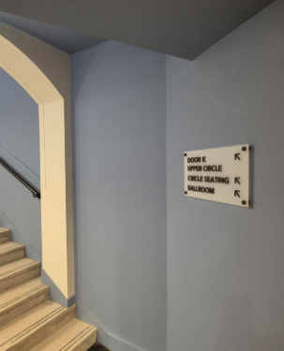
Stairway K (Blue)

Steps from Stalls Foyer to Circle via Corridor G (Yellow) - 28 steps
Steps from Stalls Foyer to Circle and Ballroom via Corridor K (Blue) - 28 Steps

There are six steps leading up to the rear of the Circle level, via Doors E and F

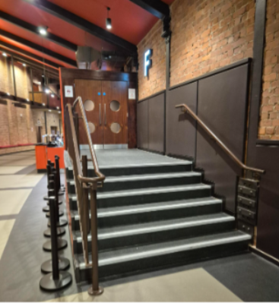

Row G in the Circle can be accessed without any further steps, Rows A-F can be accessed via further steps (two down per row). The central aisles do not have a handrail, however the side aisles do have handrails to help.

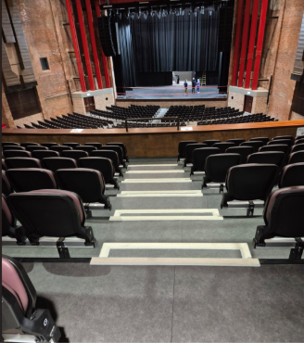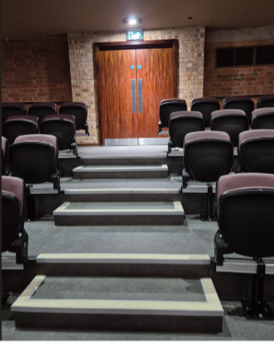
Circle Level Steps – no handrails on central aisles

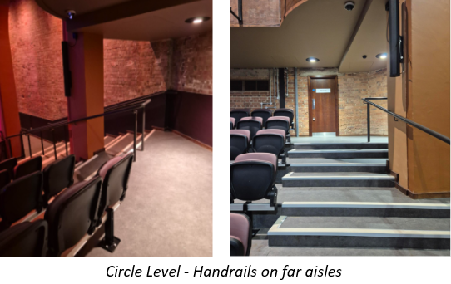

There are Gents toilets and an accessible toilet situated just off from the circle foyer (step free). Ladies toilets are situated between the Circle and Upper Circle levels and can only be accessed via steps. Alternative toilets are situated in the Basement level which can be reached via either lift or stairway.

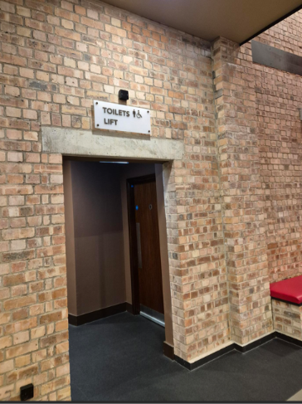
Entry to lift and accessible toilet via Circle Bar / Foyer

Steps from Circle to Ladies Toilets via Corridor G (Yellow) - 26 steps
Steps from Circle to Ladies Toilets via Corridor K (Blue) - 25 steps

Ballroom (Circle Level)

The Ballroom is situated on the Circle level and can be accessed from Stairway K (Blue) and via the lift situated by the Thornton Road entrance.

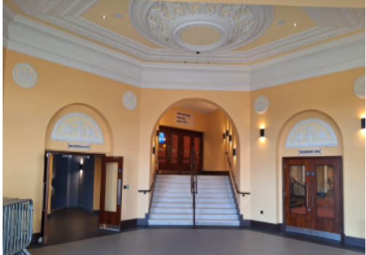

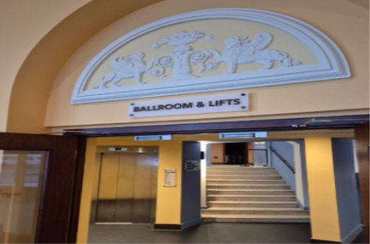

Both stairway and lift will bring you to the rear of the Ballroom, which is step-free throughout.

Steps from North Entrance to Ballroom via Corridor K (Blue) - 38 steps (28 steps via Stalls Foyer)

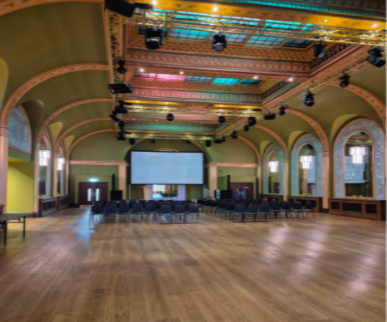

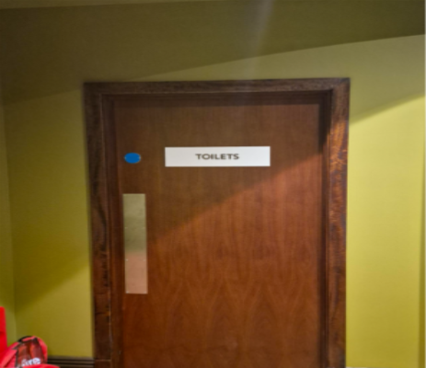

Ladies, Gents and one accessible toilet is located on the left side of the ballroom.

Upper Circle
The Upper Circle level can be accessed via both stairways and lifts. Stairway G (Yellow) will take you to Door G, Stairway K (Blue) to Door K.

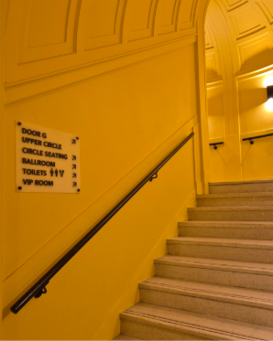
Stairway G (Yellow) Stairway K (Blue)

Steps from Stalls Foyer to Upper Circle via Corridor G (Yellow) - 74 steps
Steps from Stalls Foyer to Upper Circle via Corridor K (Blue) - 73 Steps

The lift situated in the Stalls Bar / Foyer area will take to you to Door H, and the lift situated in Stairway K will take you to Door J. Both options allow for step free access to Row L 29-56 on this level.

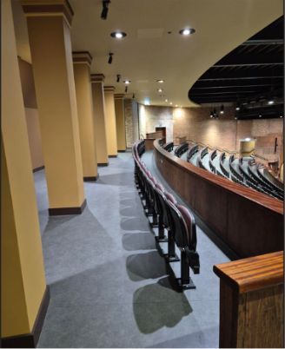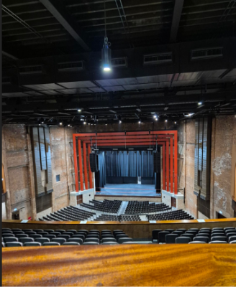
Upper Circle Row L 29-56 View from Upper Circle Row L 29-56

The lift situated in Stairway K will also stop by Door K and offers step free access to Row K 1-12.

Same as the Circle level, the central aisles do not have a handrail to aid you, however the side aisles do have handrails to help. There are two steps down per row:

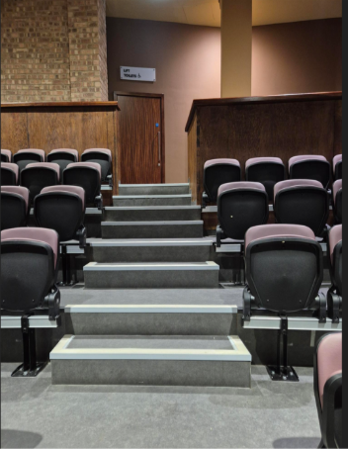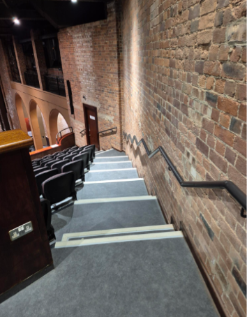
Central aisles do not have handrails Side aisles have handrails

Steps Information

South Side (Box Office and Corridor G)
- Stalls Foyer to Boiler Room Bar – 24 steps
- Stalls Foyer to Basement via Green stairway – 18 steps
- Stalls Foyer to Gaumont Bar – 9 Steps
- Stalls Foyer to Circle Foyer – 28 steps
- Circle Foyer to Ladies toilets – 26 steps
- Stalls Foyer to Upper Circle – 74 steps
- Circle Foyer to Upper Circle – 46 steps
- Upper Circle to Ladies Toilets – 26 steps

North Side (Gaumont Bar and Corridor K)
- North Entrance to Basement – 9 steps
- North Entrance to Stalls Foyer (via Corridor K and main stairway) – 10 steps
- Stalls Foyer to Gaumont Bar – 9 steps
- Stalls Foyer to Circle Foyer and Ballroom – 28 steps (38 steps from North Entrance)
- Circle Foyer to Ladies toilets – 25 steps
- Stalls Foyer to Upper Circle – 73 steps
- Circle Foyer to Upper Circle – 22 steps
- Upper Circle to Ladies Toilets – 25 steps

