Easy Read
Green Man Accessibility Information 2026

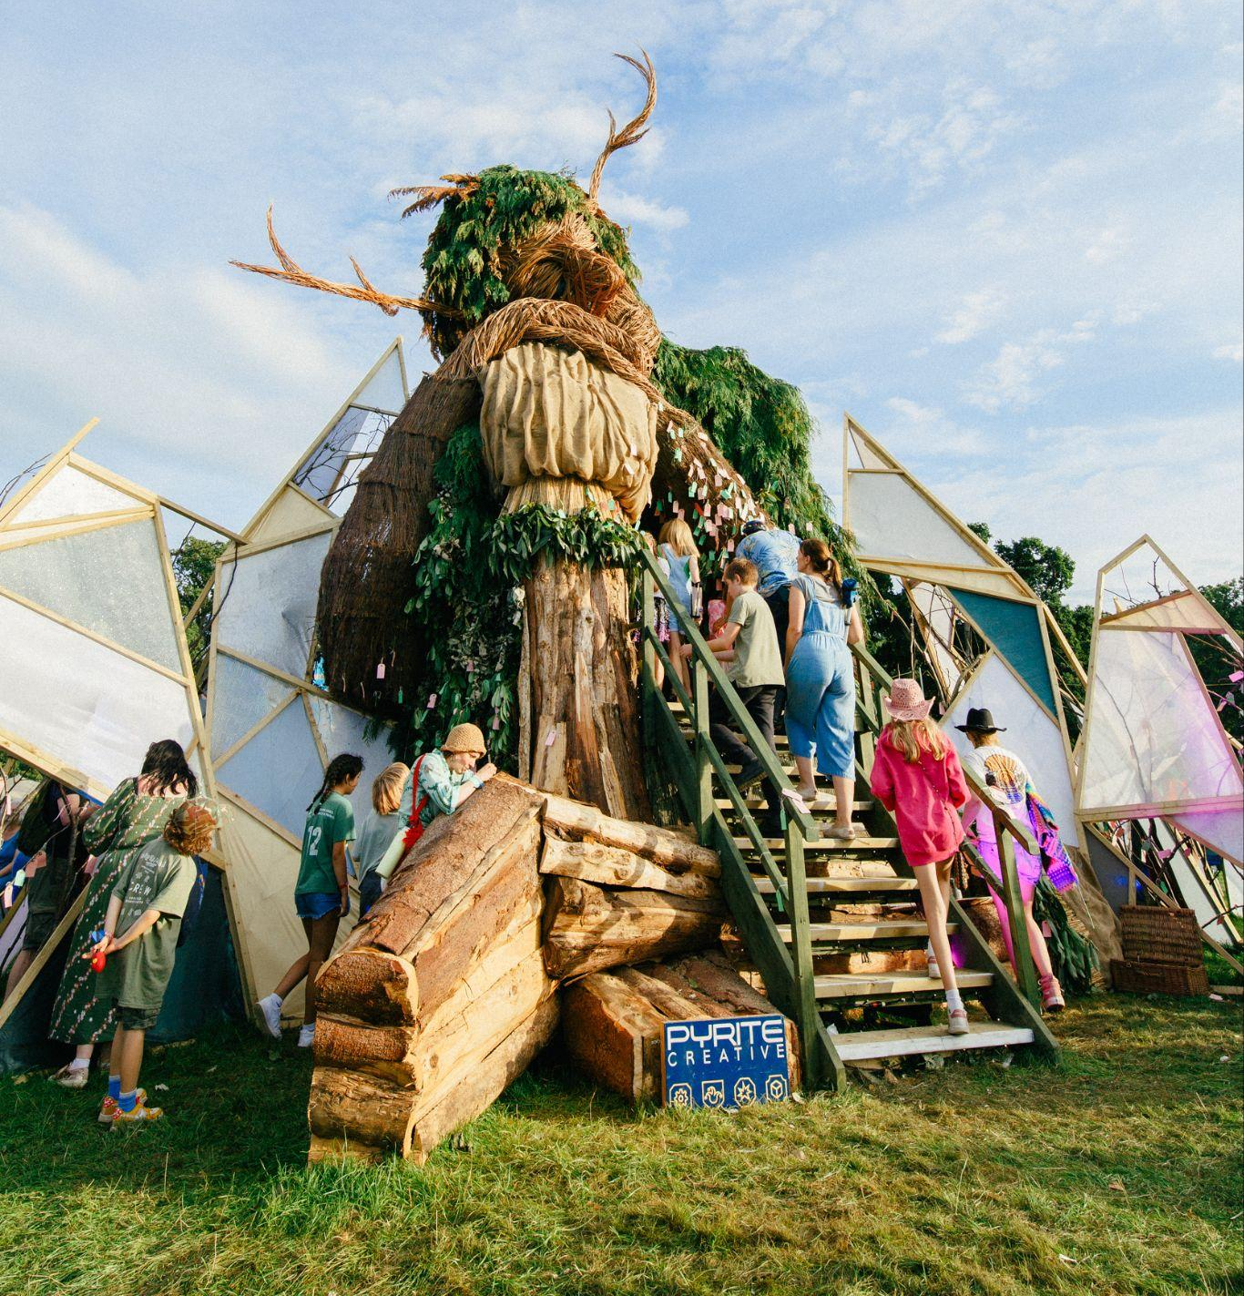 | This booklet contains information about the accessibility services at Green Man festival.
 | Email Green Man:  You can email a person from the Green Man team on accessibility@greenman.net.
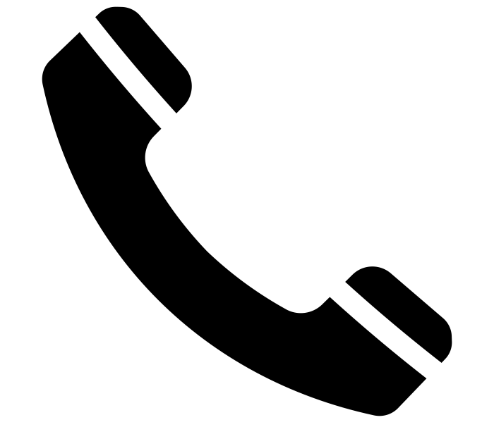 | Telephone Green Man:  You can book for someone from Green Man to call you by visiting gmfe.st/call-back.
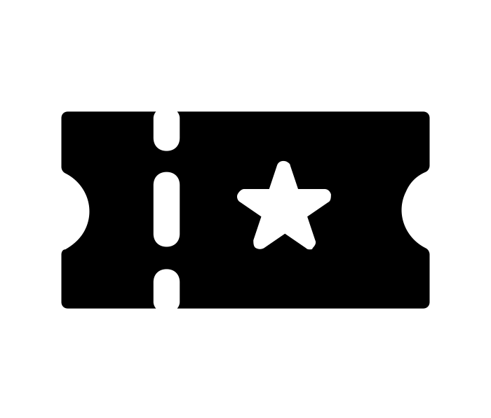 | Access Tickets and Passes:  Requests for additional access tickets and passes close 5pm Saturday 19th July.  These are for people with long term disabilities and health conditions. This is not for people with temporary injuries.  If you need any of the following tickets please email accessibility@greenman.net. They will send you a form to fill out. You will need to give evidence.  Here are the tickets and passes that are available:
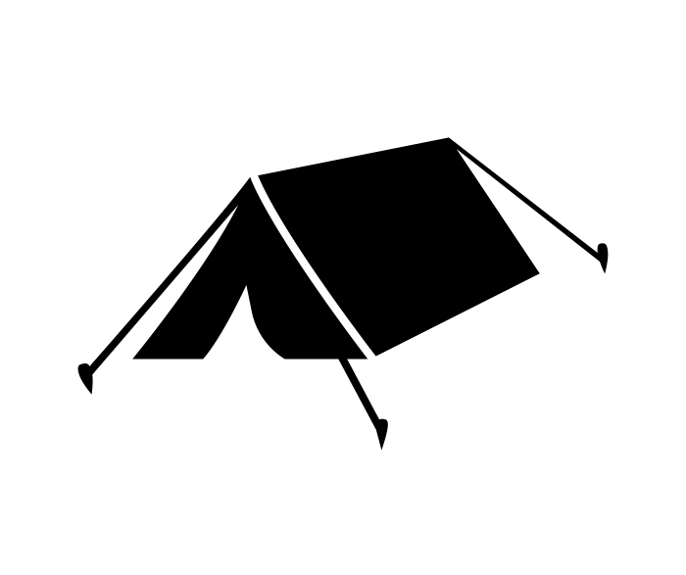 | Tickets for accessible campsite  You do not need to book a pass to camp in the accessible campsite.
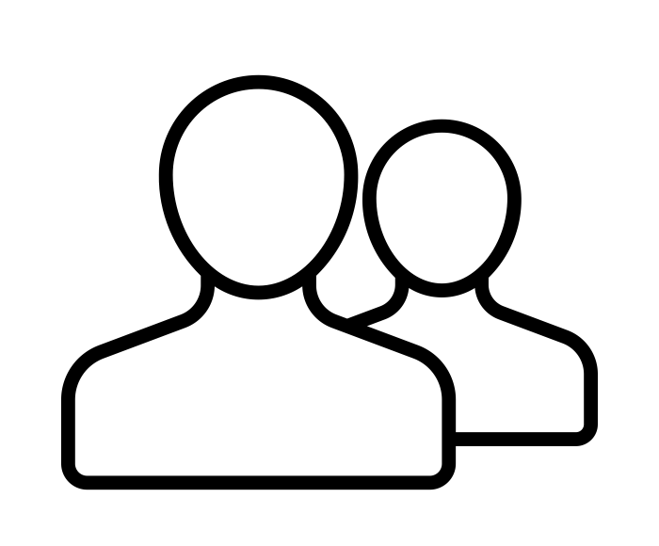 | Companion ticket at no extra cost  For people who would not be able to go to the festival on their own because of their disability.  This is only if you already have a student or adult ticket and would be unable to attend on your own.  Your companion must be aged 16 or over.  If you are attending with a disabled child under 18 with very high care needs, please email accessibility@greenman.net.
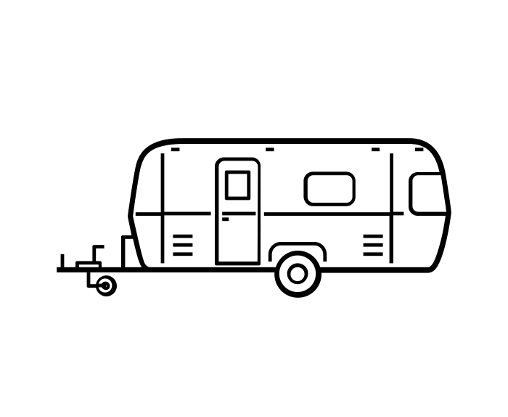 | Accessible Live-In Vehicle Pass  If you want to bring your caravan or campervan you need this pass.  You will be in the accessible campsite  You will have an area to park your caravan or campervan in which is 6 metres wide.  There are no power or water hook-ups for vehicles.
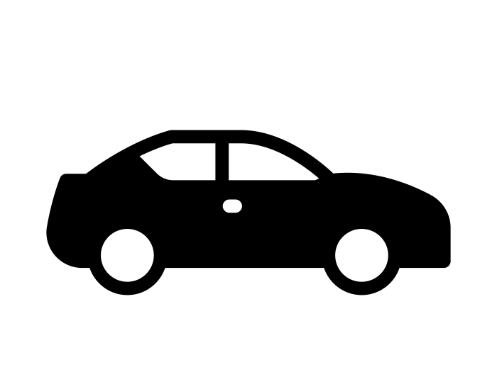 | Accessible Car Park Pass  The car park is close to the box office and accessible campsite.  You can park in the accessible car park.
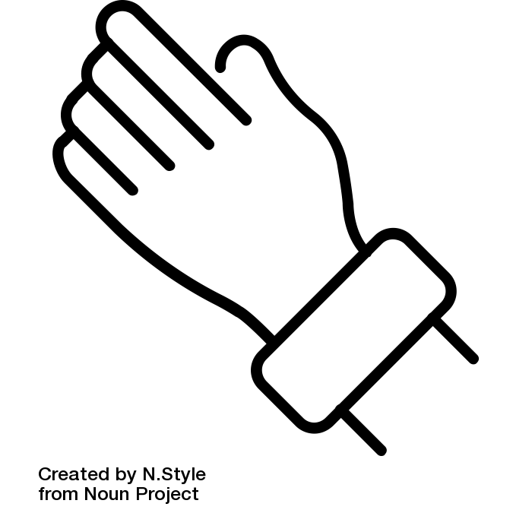 | Viewing Platform Wristband  Lots of our stages have a viewing platform so you can see the stage.  Viewing platforms are for disabled customers and one adult companion.  Accessible toilets will be available next to each viewing platform.
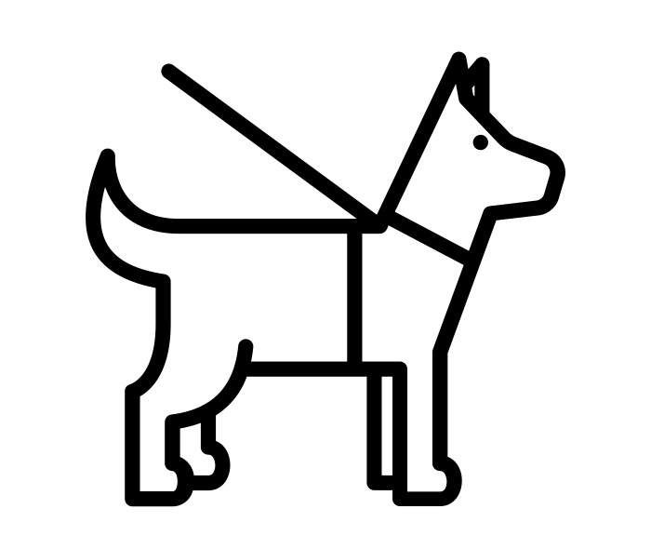 | Assistance Dogs  If you need to bring an assistance dog you need to let us know by emailing accessibility@greenman.net.  These are the rules you need to follow:  - Assistance dogs must be wearing a working jacket in the main arena  - You must clear up after your dog  - You are in charge of the dogs behaviour
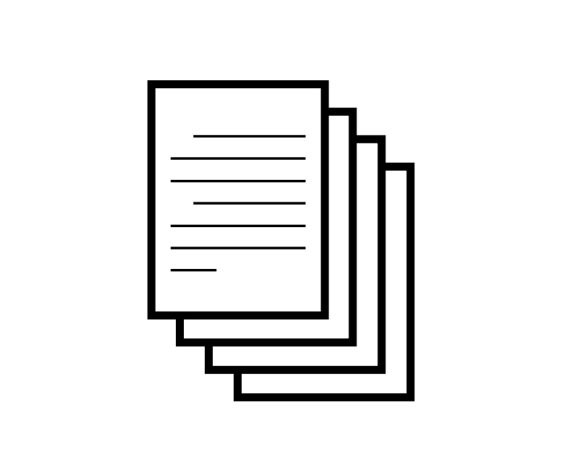 | Evidence for any accessibility passes  When you apply for any accessible pass you will need to give us some evidence. It can be any of the following items  - Access card with the +1 symbol  - Access card with the Distance or Wheelchair symbol  - A letter showing you get the ‘Daily Living’ component of PIP or DLA with an expiry date being after the festival  - A letter showing you get the ‘Getting Around’ or ‘Mobility’ component of PIP or DLA with an expiry date being after the festival  - A letter showing you get Attendance Allowance or Employment and Support Allowance dated within the last 12 months.  - Both sides of your Blue Badge  - Proof you are registered as severely sight impaired  - Proof of being diagnosed on the autistic spectrum  - A letter from a doctor confirming you could not attend the festival alone or you have a disability or condition that requires you to use the accessible campsite or car park.
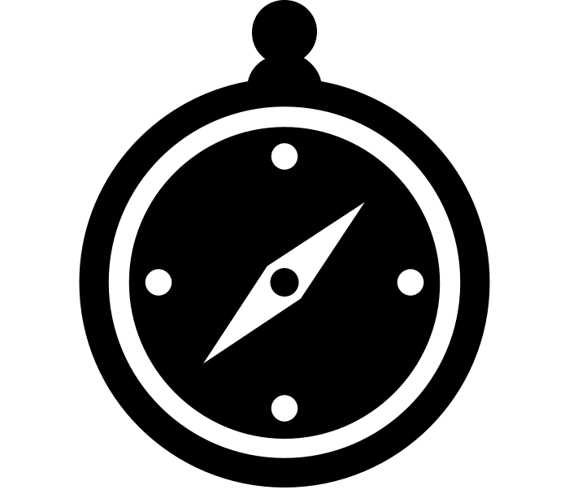 | Accessible Travel and Arrival Information  For full travel details please visit our Getting Here page at www.greenman.net/information/getting-here/.
By Car:

If you are driving to the festival to the Accessibility Campsite, follow signs to Settlement Gate.

If you are being dropped off by car you will need an Accessible Car Park Pass to allow you on site.

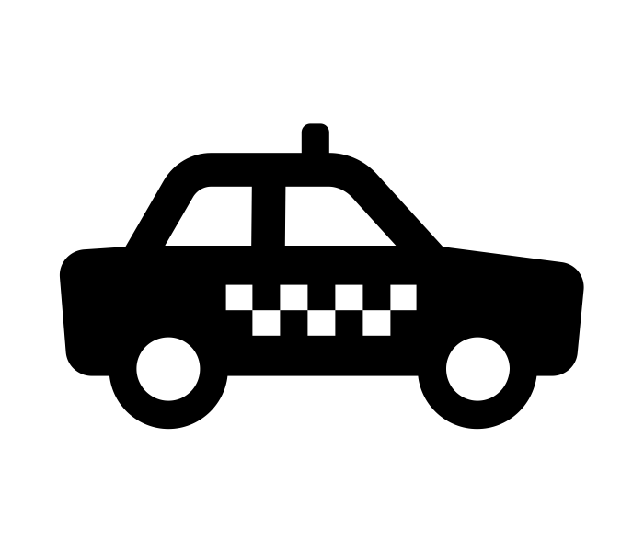 | By Taxi:  If you are coming to the festival by taxi, tell the taxi driver to go to the Settlers’ Gate and tell the people there you are a disabled customer.  The taxi will then drive to the Accessible Car Park.
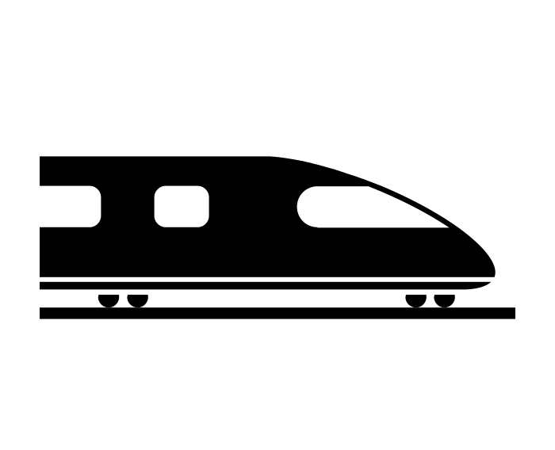 | By Train:  If you are coming by train and need a free accessible shuttle from the station please email accessibility@greenman.net by 4th July 2026.
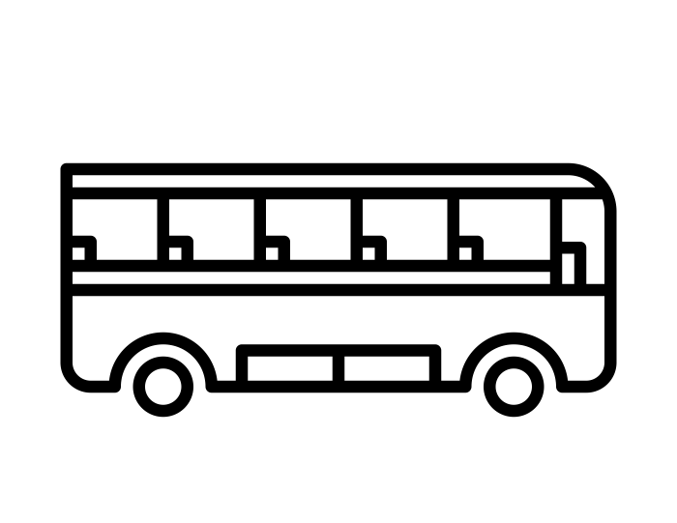 | By Coach or Shuttle Bus:  If you are coming to the festival by coach or bus, please email accessibility@greenman.net to arrange to be collected from the bus gate by our accessibility golf buggy.
Accessible Campsite Facilities

Our accessible campsite has two sides of trackway and is next to the main tarmac road that runs through the festival.

The campsite is not far from the main stage, the music finishes at 00:30 each night.

Groups of up to 4 adults plus their dependent children can camp in the accessible campsite per disabled customer.
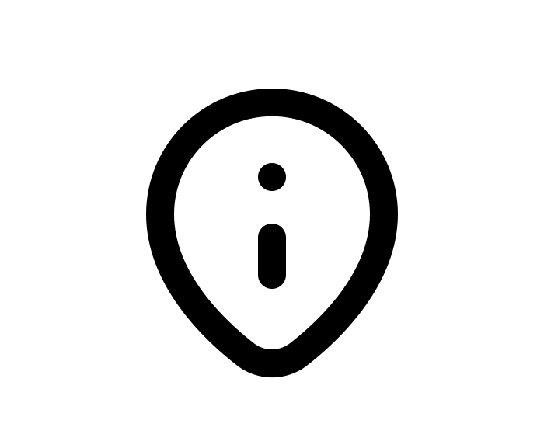 | Facilities available in the Accessible Campsite  - Accessible showers  - Accessible toilets  - High Dependency Unit: a toilet with running water and an electric hoist  - 24 hour covered charing point for power chairs and mobility scooters  - Mobility scooter and wheelchair hire from Event Mobility  - Accessibility info tent  - Respite tent - if you need a quiet space away from the festival  - Fridge for medicines
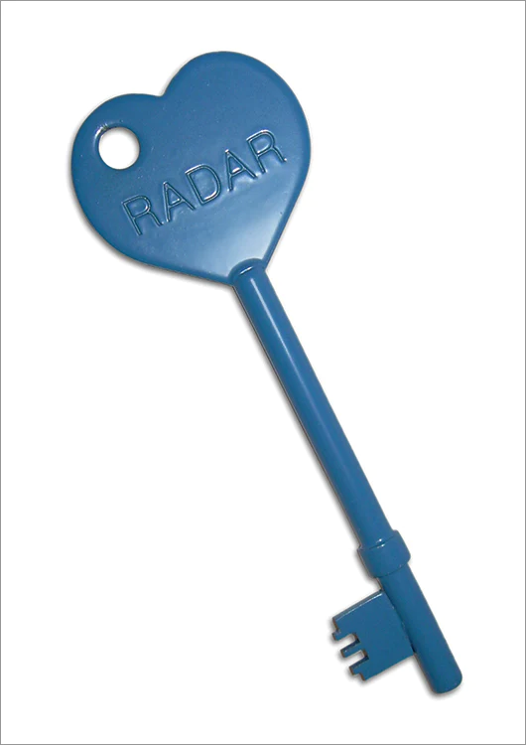 | RADAR Keys  RADAR keys are used on our accessible toilets and showers.  You can bring your own RADAR key or borrow one from the Accessibility Information tent for a £10 deposit
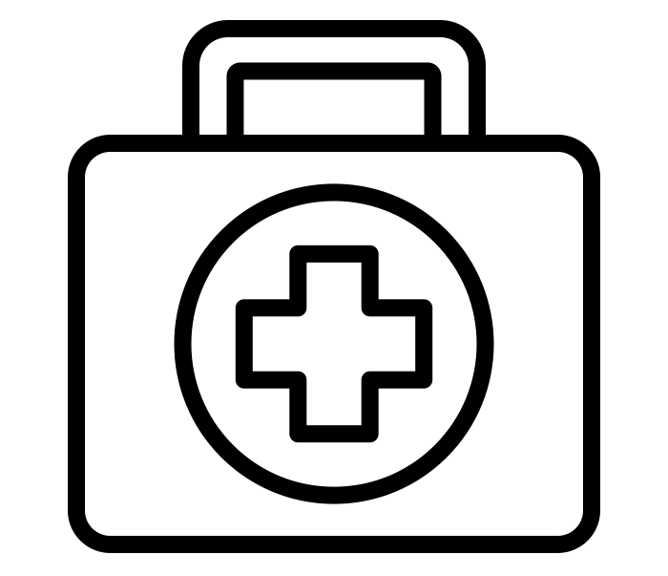 | Medical Services  Medical services are located in the First Aid area of Babbling Tongues.  You can ask a steward in orange high-vis to call them for you.  There are doctors, paramedics, and an ambulance.
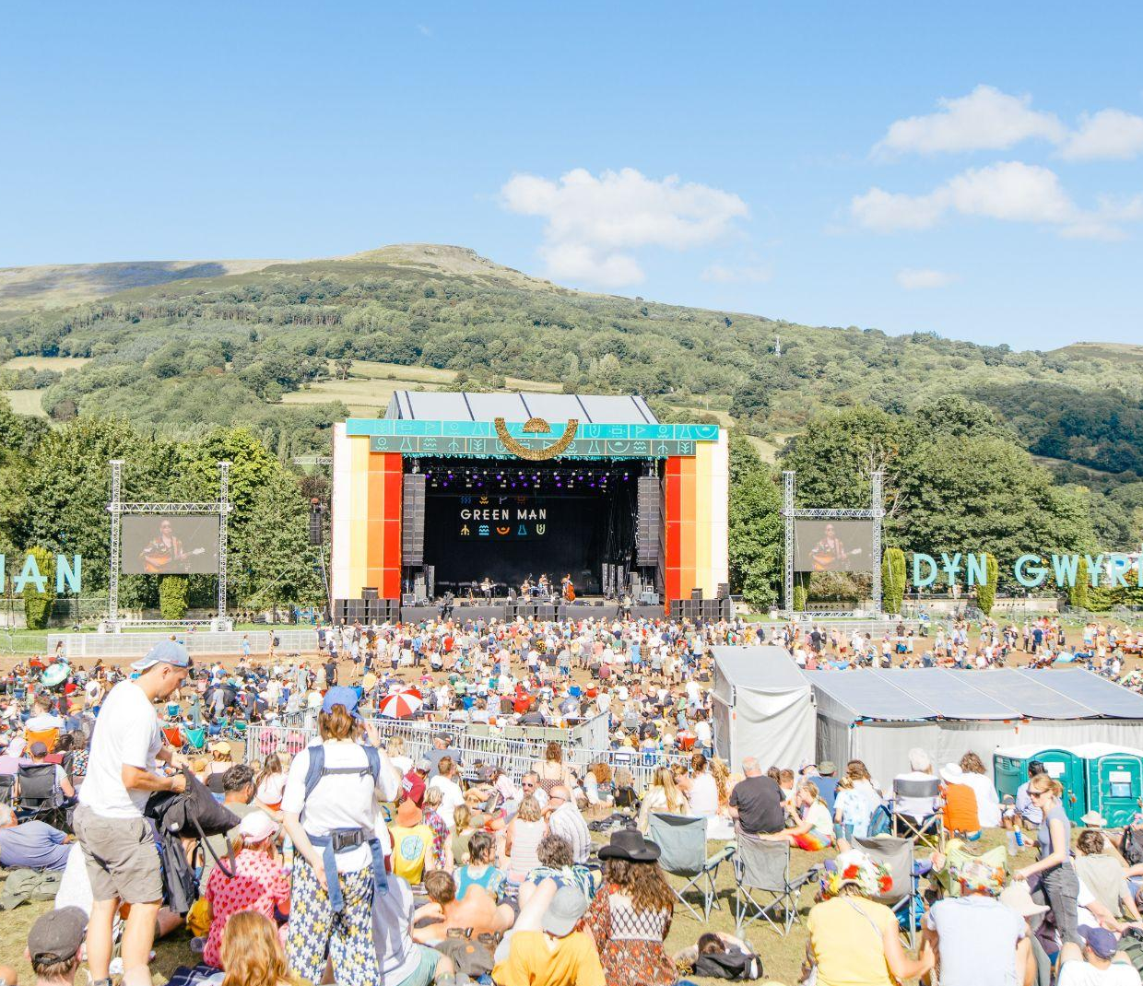 | Main Arena Accessible Facilities  Please email accessibility@greenman.net if you have any questions about the below information.
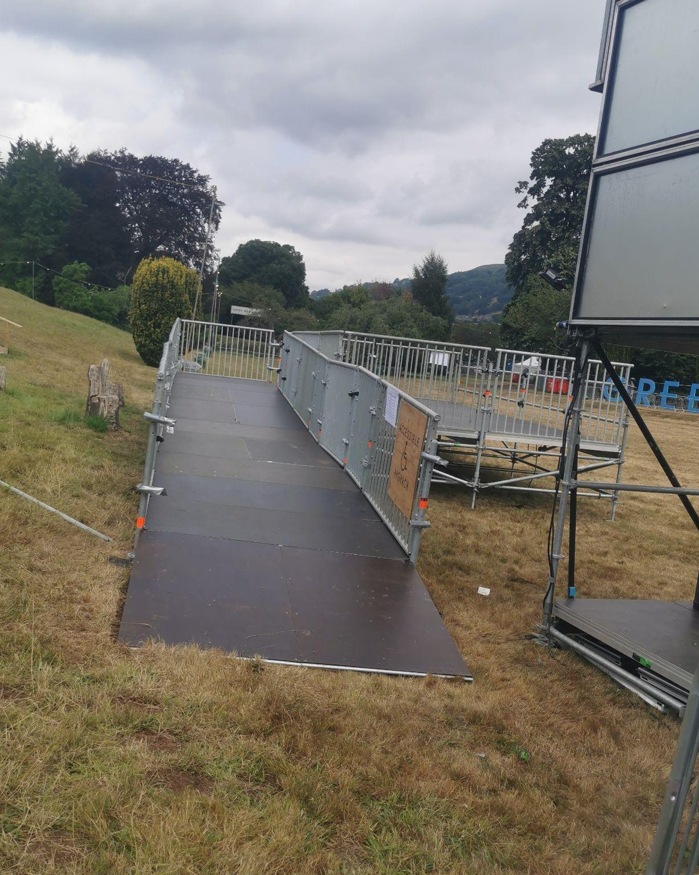 | Viewing Platforms  These stages have viewing platforms: Mountain Stage, Far Out Stage, Walled Garden Stage, Rising Stage, Chai Wallahs.  There will also be a viewing platform on Sunday night next to the Green Man before it is burnt.  You need to apply for a viewing platform wristband to use them (above).  Viewing Platforms are only for disabled people and one companion.  Accessible toilets will be next to every viewing platform.
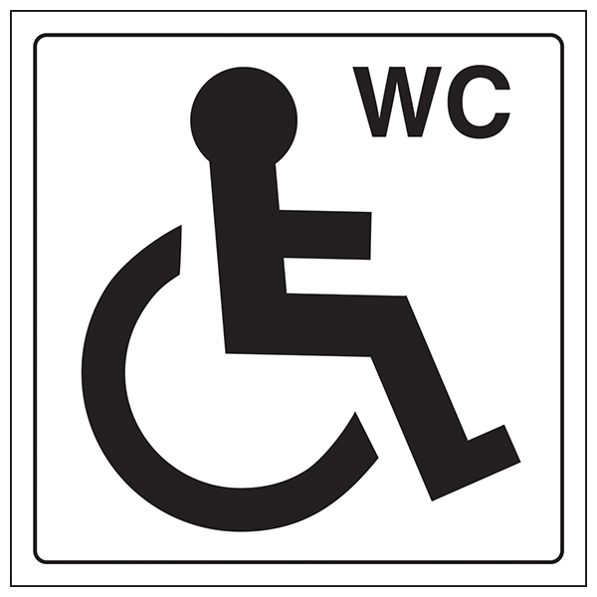 | Accessible Toilets  There are accessible toilets in the main arena.  They are next to other toilets and next to viewing platforms.  You will need a RADAR key to open them.
 | BSL - British Sign Language  Some of our main stage performances will have sign language interpreters.  They are also available to book to interpret anything around the festival.
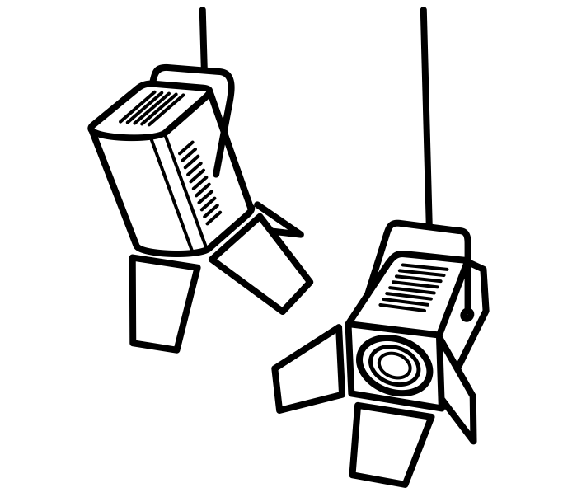 | Lights  There may be flashing lights and strobe effects on all stages.  Lasers may also be used.
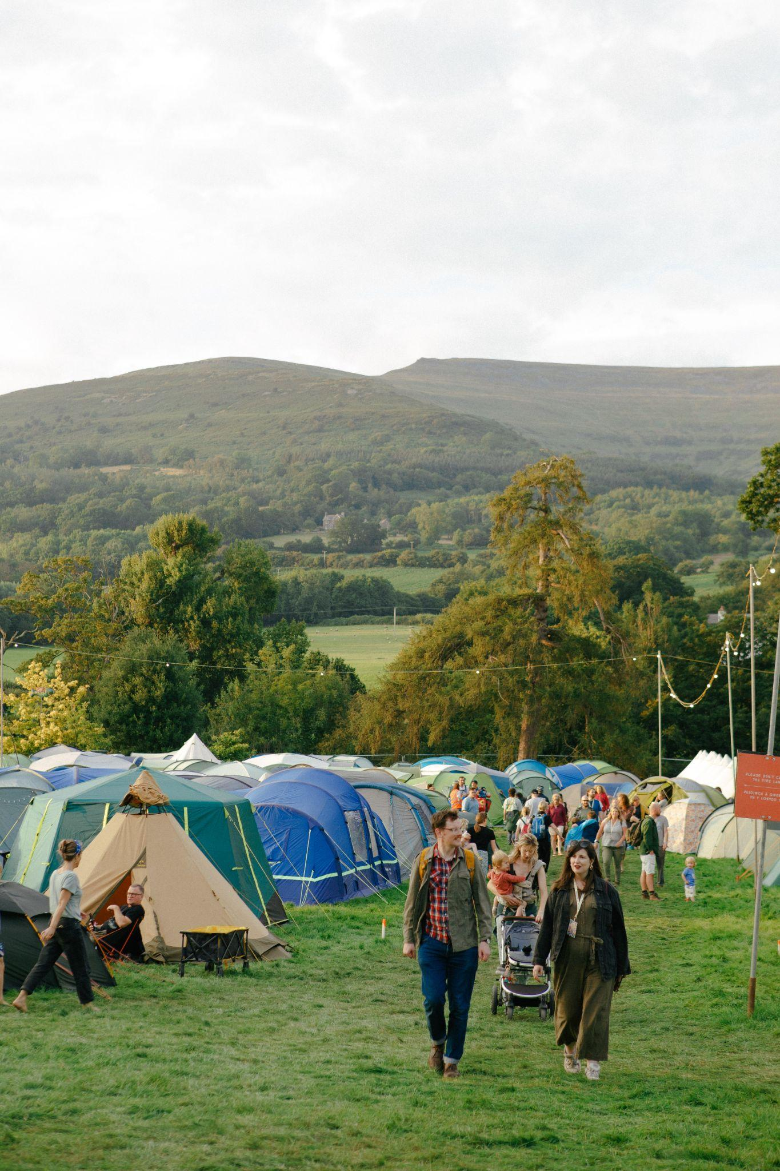 | Access Around Site  Green Man happens in a big field with some woodland around it.  A map of the 2025 site showing the roads with hard surfaces can be seen at gmfe.st/routes.  A map of 2026 will be available nearer the festival.
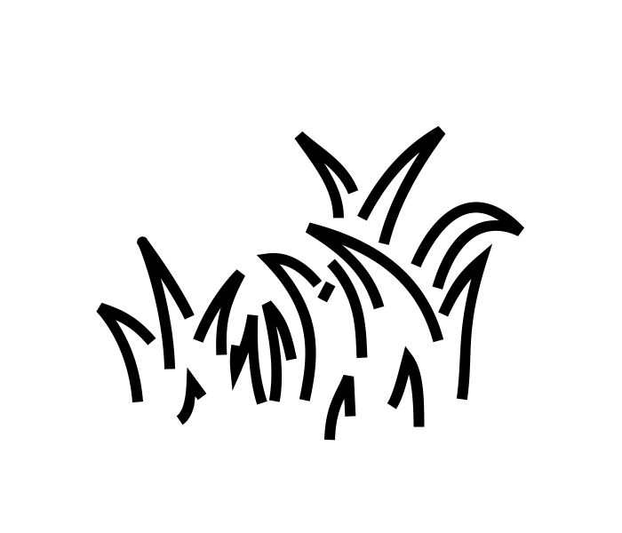 | Ground Surface  Most of the festival is grass. This gets very muddy when wet.  A tarmac road runs through the middle level of the festival.  There is a trackway leading up to the Far Out viewing platform.
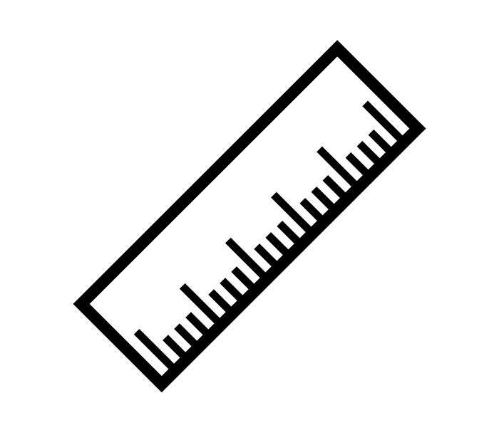 | Distances  The festival is small but spread out over quite a distance.  The main stage is a 200m walk from the accessible campsite and all stages are within 650m.
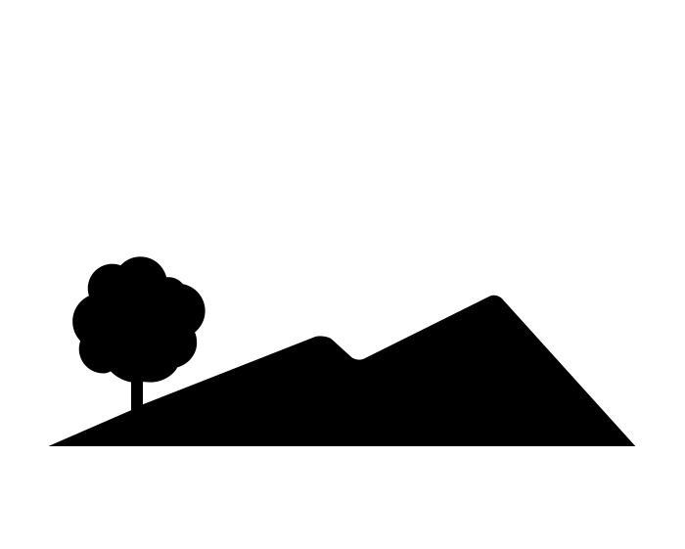 | Gradients  The site is set out over 3 levels.  Low level: Camping, Little Folk, Fortune Falls, Mountain Stage  Medium level: Walled Garden, Babbling Tongues, Courtyard, Nature Nurture  Upper level: Cinedrome, Chai Wallahs, Wishbone, Round the Twist, Far Out, Somewhere  The natural gradient may be an issue for people who use manual wheelchairs and anyone with serious mobility impairments.  Electric wheelchairs can get to most areas without any issue.  The ground is uneven in places.
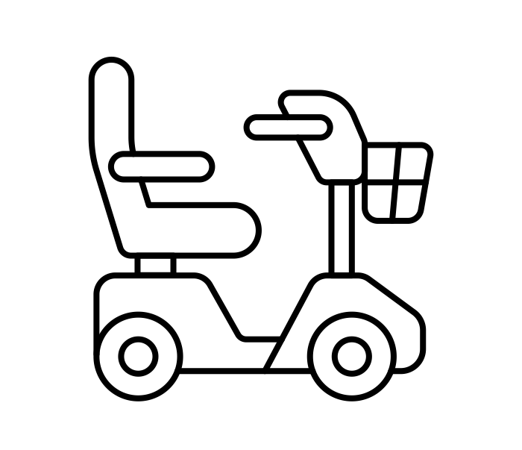 | Event Mobility Scooter Hire  Event Mobility hire electric wheelchairs and mobility scooters for the festival.  Contact them through www.eventmobility.org.uk for further information.  You can book for the 2026 festival at https://www.eventmobility.org.uk/green-man-festival.
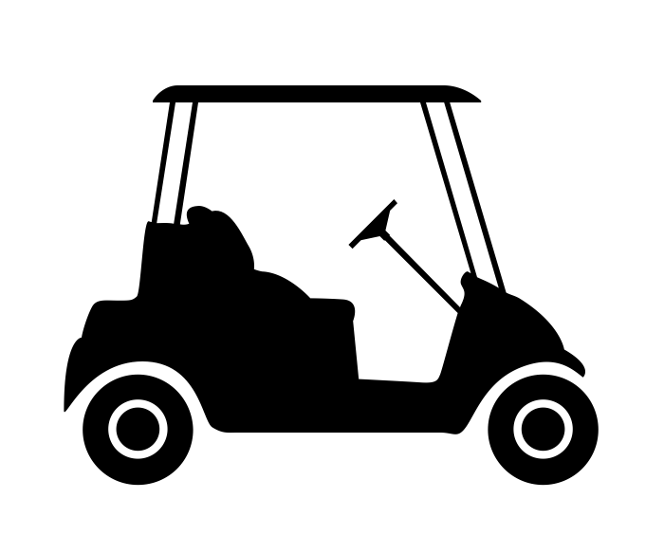 | Accessibility Golf Buggy  There is a dedicated wheelchair accessible golf buggy to help get you around.  Please pre-book at the accessibility information tent to avoid long waits.

